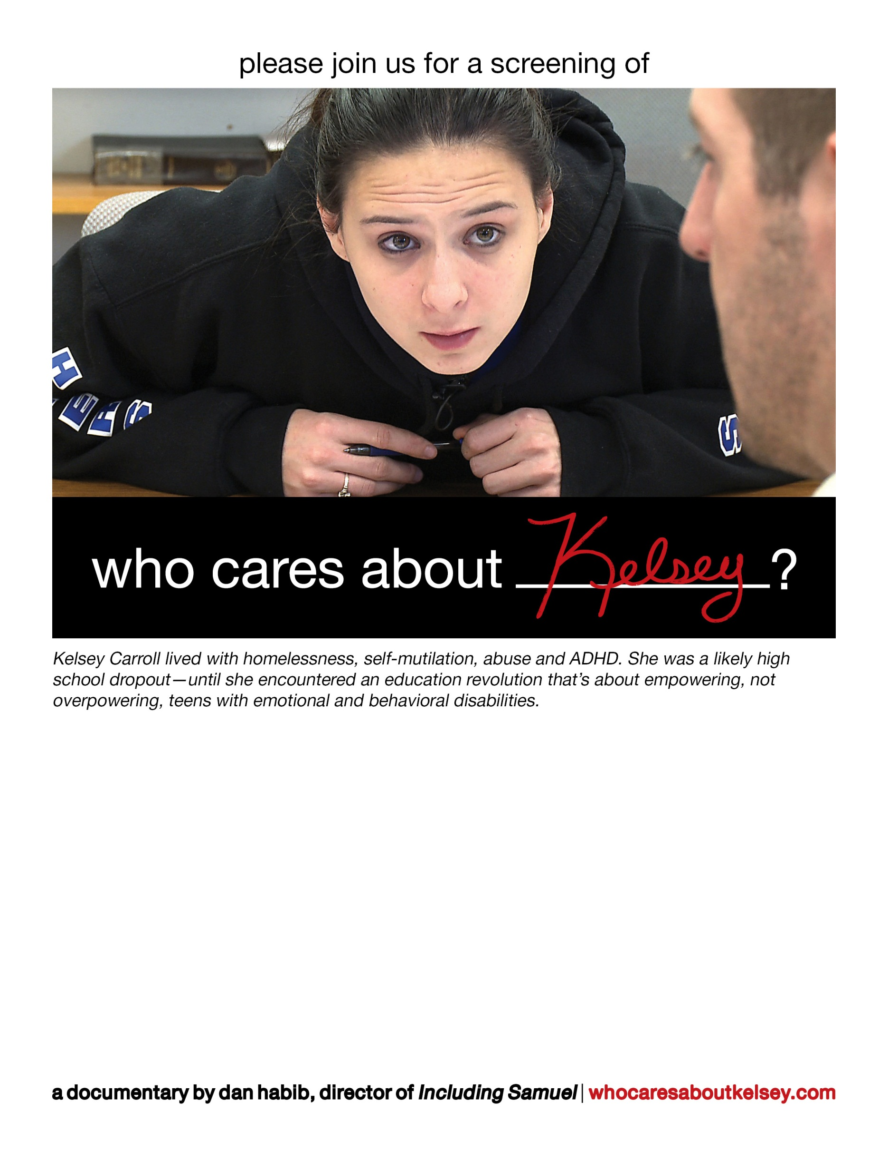

**CLICK HERE to insert text and logos about your screening!**

For example:

Tuesday, September 18, 2012

4:00pm - 6:30pm

Rivier University Dion Center

420 South Main Street, Nashua, NH

Free and open to the public | Open captioned

Screening will be followed by a Q&A with filmmaker Dan Habib and Kelsey Carroll

Reserve tickets at www.xxxxxxxxx.com or call XXX-505-5708

*To insert a logo, click outside this box and insert it independently so it’s easier to move around, or right click the IOD logo that’s already inserted and select “change picture.”*